**Principal Components 1**

Turbine 1 *(Gen_RPM_Avg', 'Gen_Bear_Temp_Avg’)* vs Others (*'Rtr_RPM_Avg', 'Amb_WindSpeed_Avg'*)

Turbine 6 Turbine 7 Turbine 11

Turbine 6 *(Gen_RPM_Avg', 'Gen_Bear_Temp_Avg’)* vs Others (*'Rtr_RPM_Avg', 'Amb_WindSpeed_Avg'*)

Turbine 1 Turbine 7 Turbine 11

Turbine 7 *(Gen_RPM_Avg', 'Gen_Bear_Temp_Avg’)* vs Others (*'Rtr_RPM_Avg', 'Amb_WindSpeed_Avg'*)

Turbine 1 Turbine 6 Turbine 11

Turbine 11 *(Gen_RPM_Avg', 'Gen_Bear_Temp_Avg’)* vs Others (*'Rtr_RPM_Avg', 'Amb_WindSpeed_Avg'*)

Turbine 1 Turbine 6 Turbine 7

**Principal Components 2**

Turbine 1 *('Blds_PitchAngle_Avg', 'Nac_Direction_Avg')* vs Others (*'Amb_WindSpeed_Avg'*)

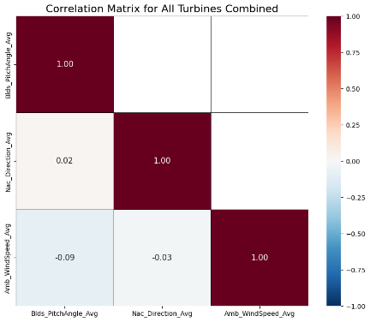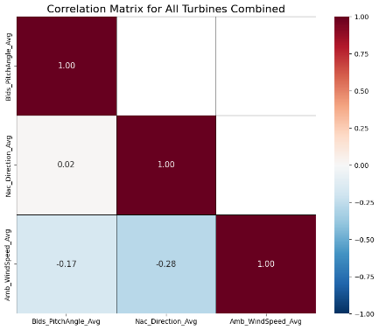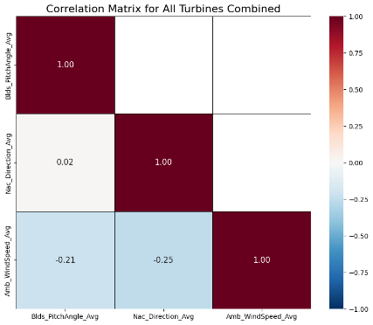

Turbine 6 Turbine 7 Turbine 11

Turbine 6 *('Blds_PitchAngle_Avg', 'Nac_Direction_Avg')* vs Others (*'Amb_WindSpeed_Avg'*)

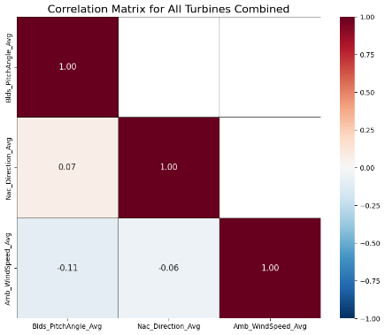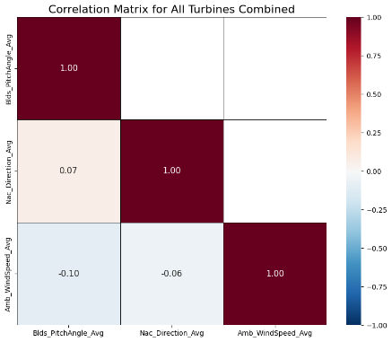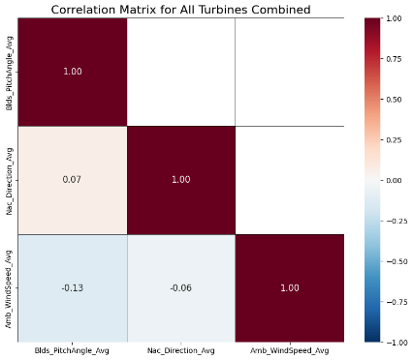

Turbine 1 Turbine 7 Turbine 11

Turbine 7 *('Blds_PitchAngle_Avg', 'Nac_Direction_Avg')* vs Others (*'Amb_WindSpeed_Avg'*)

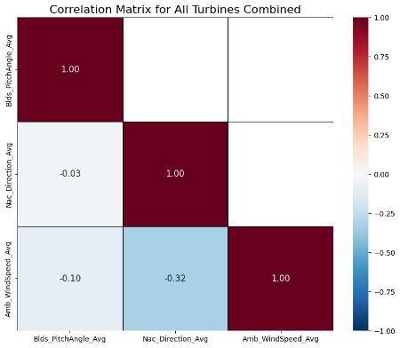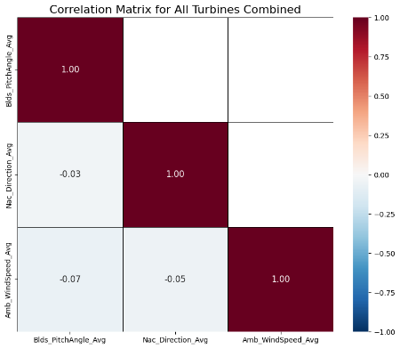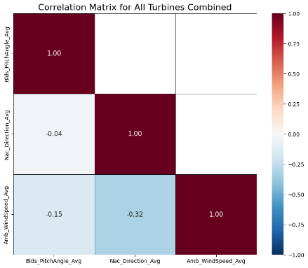

Turbine 1 Turbine 6 Turbine 11

Turbine 11 *('Blds_PitchAngle_Avg', 'Nac_Direction_Avg')* vs Others (*'Amb_WindSpeed_Avg'*)

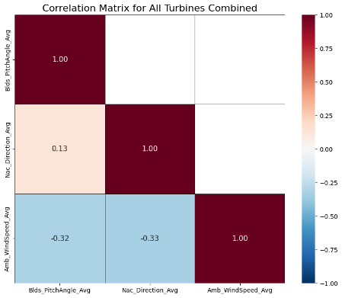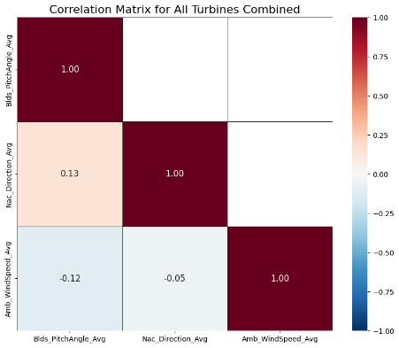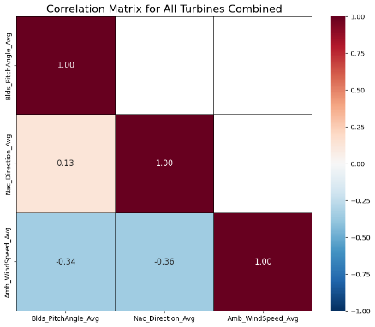

Turbine 1 Turbine 6 Turbine 7

**Principal Components 3**

Turbine 1 *('Blds_PitchAngle_Avg')* vs Others (*'Nac_Direction_Avg'*)

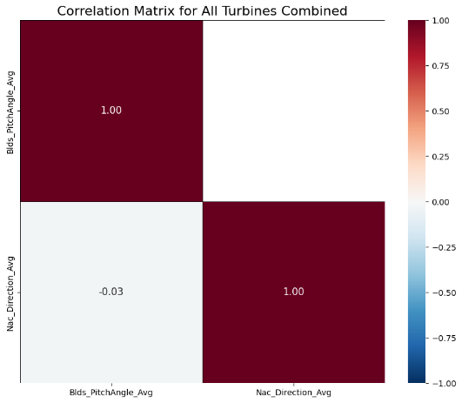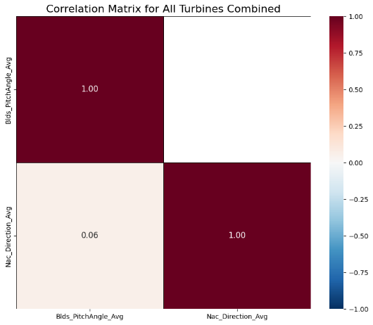

Turbine 6 Turbine 7 Turbine 11

Turbine 6 *('Blds_PitchAngle_Avg')* vs Others (*'Nac_Direction_Avg'*)

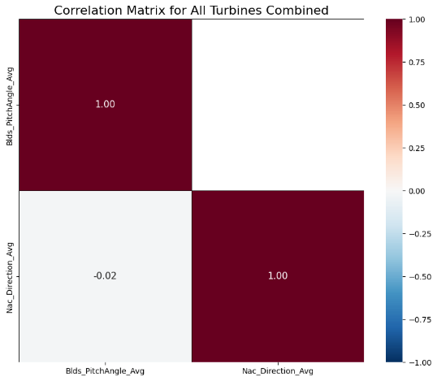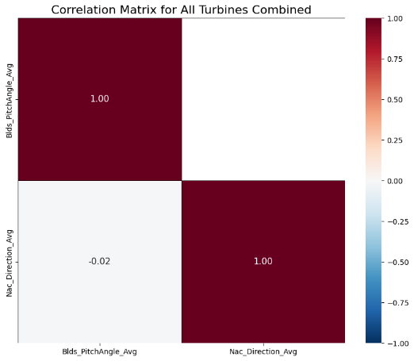

Turbine 7 Turbine 11

Turbine 7 *('Blds_PitchAngle_Avg')* vs Others (*'Nac_Direction_Avg'*)

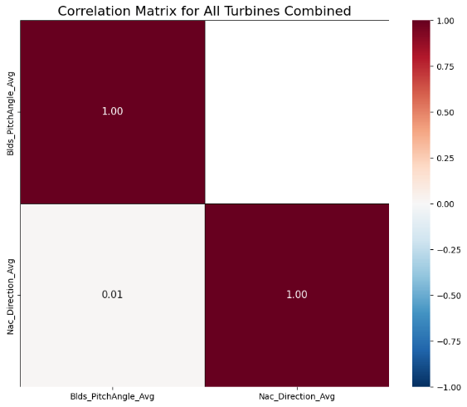

Turbine 11